**XR3 Fluoroscopy Handout**

*Bolded words/sentences will be removed to be filled in by audience during presentation.

1. In one sentence, what distinguishes fluoroscopy from other x-ray techniques?
   1. **Fluoroscopy samples images at a faster rate, allowing for many images to be taken throughout an exam and displayed in video format.**
   2. **Or simply, video x-ray!**
2. Images on a fluoroscopy machine can be sampled using two different types of x-ray beam: _**continuous**_____ and __**pulsed**_____. __**Continuous**____ sampling gives a sampling rate of __**33ms**____ while __**pulsed**__ sampling gives a sampling rate of __**3-10ms**____. Blurring may occur due to movement using **_continuous_** sampling, while this is less likely to be an issue using **_pulsed_** sampling.
3. The image __**quality**___ is the same between these two different types of sampling. This is calculated as __**area under curve/total signal per pulse (any equivalent works)**.
4. Name the two types of receivers used in fluoroscopy systems. Highlight the more modern one.
   1. **Image Intensifier**
   2. **Flat panel**
5. The AERC circuit is a __**feedback**____ circuit driven by the ___**sensor**_____. This circuit helps to keep __**SNR**___ constant by _**increasing**____ or _**decreasing**____ the strength of the x-ray beam.
   1. Which components of the x-ray system are altered to change beam strength?
      1. **mA and kV**
   2. This is a trade off between __**dose**___ and _**contrast**____ altered by the _**attenuation**__ caused by the patient.

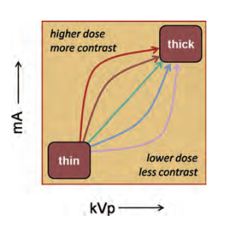

**Figure 1**. Dose/Contrast trade off curves. The AERC circuit controls the dose/contrast ratio to keep image quality constant as the x-ray beam is attenuated by patient thickness.

1. What is the name (acronym) of the flesh analog used to test radiation dosage?
   1. **PMMA**
2. Who is at risk of x-ray radiation during a fluoroscopy procedure?
   1. **Patient**
   2. **Personnel (i.e., surgeon, x-ray techs, anyone else in the room)**
3. Name 2 common use cases of fluoroscopy.
   1. **Surgical guidance**
   2. **Rapid diagnostics**
   3. **Angiography**
   4. **GI diagnostics**

**(any two work)**

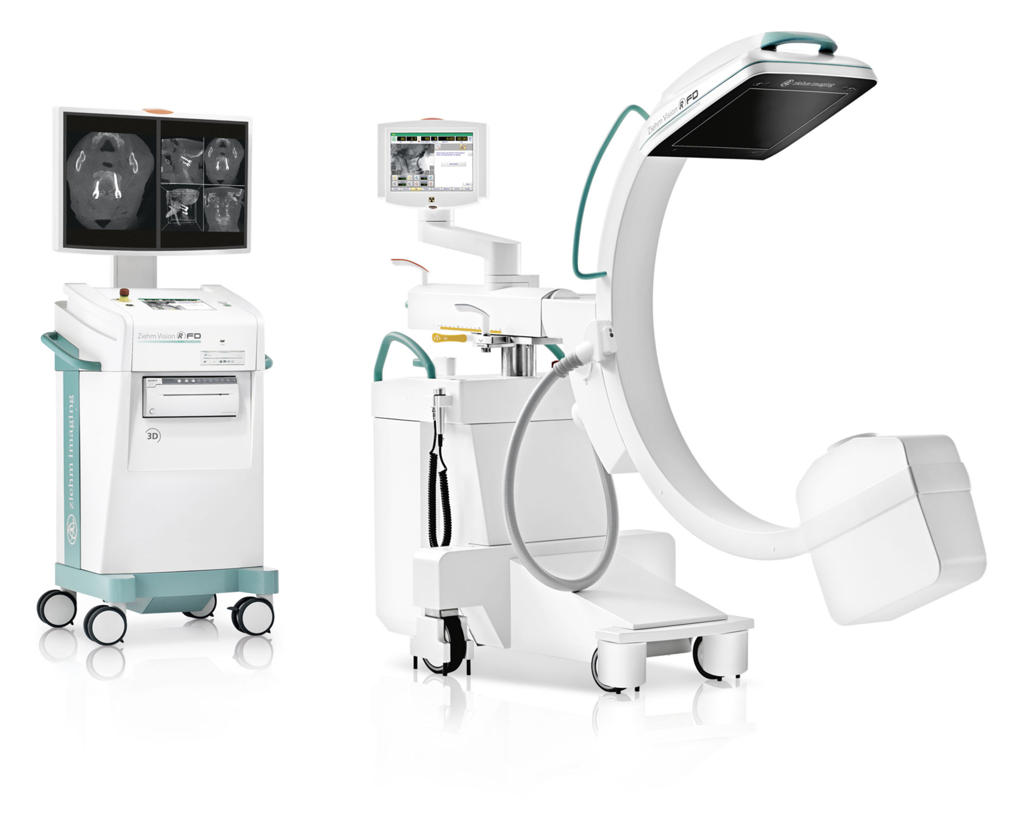

**Figure 2.** C-Arm Design (named for its shape) is a portable fluoroscopy machine that allows for quick real time imaging!

9. The receiver in this image is:

1. **Flat Panel**
2. Image Intensifier
3. What is the name of the principle that we always want to keep in mind when using fluoroscopy?
   1. **ALARA! → Very important to monitor dosage!**